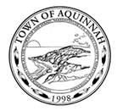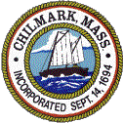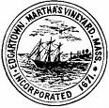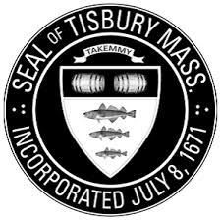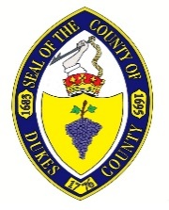

FOR IMMEDIATE RELEASE

Contact:
Russell Hartenstine
Public Information Officer
Martha Vineyard Regional Emergency Planning Committee
(508)-693-5380
emd@westtisbury-ma.gov
Saturday, March 21, 2020

Martha's Vineyard Hospital and Nantucket Cottage Hospital are urging residents and visitors of the islands to consider the limitations of our critical access hospitals during this unprecedented time of pandemic. For your safety and to save lives, we strongly advise you to STAY AT HOME. The perception that the Islands are a safe haven are not realistic given the limited number of personnel, critical supplies and beds. Our system will not be able to handle the large number of infected patients from rapid community spread which is expected. For your safety and to ensure the safety of our medical personnel on the front line we need you to do the following:

• We are asking you to stay at home
• For those Island residents, only travel for the absolute necessities, such as food or prescriptions
• If you come to the Island – you will only strain our limited resources, putting your life and others at risk
• If you have a summer home here – we are asking you to stay at your home residence – we have limited bed capacity 25 at MVH and 14 at NCH – and that is already strained
• We have limited medical resources here on the Island and they are dwindling rapidly
• We will not have enough staff to care for you or your loved ones
• Our hospitals are virtually locked down to prevent the flow of people through the facility
• We must act now – to prevent any further spread

Denise Schepici, MPH, President & CEO, Martha's Vineyard Hospital
Gary Shaw, FACHE, President & CEO, Nantucket Cottage Hospital

